VortexDeep
SLIDE TIGHTENING SPEC · v02 → v03 · remove Slide 4, split problem/solution into two process diagrams
Decision: delete Slide 4 (the “how it works” repeat). Its point — many tasks in, all handled, you decide each — is carried by a small process (P&ID-style) diagram added to Slide 2 (Problem) and Slide 3 (Solution). Deck goes from 10 to 9 slides. Same Venturelab structure; apply by hand.

Renumbering (10 → 9 slides)
1 Intro · 2 Problem · 3 Solution · [4 removed] · 4 Market · 5 Competition & Advantage · 6 Roadmap · 7 Financial Plan · 8 Team · 9 Board & Advisors. The Day 5 talking-points script (v11) is already renumbered to match.

A. Add to Slide 2 (Problem) — the bottleneck
A simple process diagram: the four task types arrive, but one resource (“You”) can only take one at a time — task 1 is resolved, tasks 2…N wait. This is the capacity problem, not just “it repeats.”
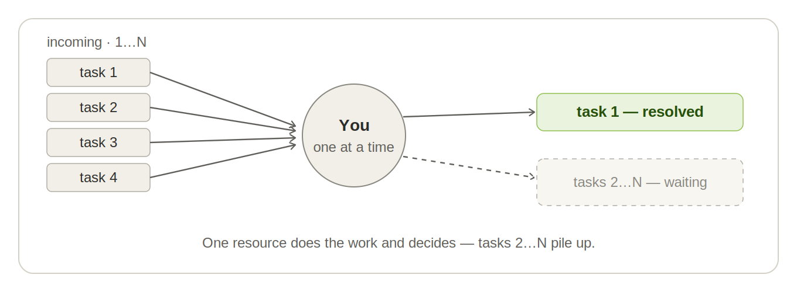
Build: 4 task chips → a circle labelled “You / one at a time” → one green “resolved” box + one dashed “waiting” box. Circle = the human as the single resource.

B. Add to Slide 3 (Solution) — the controlled line
The parallel diagram: the same inflow, but the AI workflow does the work on all tasks, and “You” become the control point on the line — approve each, all 1…N resolved. Same human authority, no bottleneck.
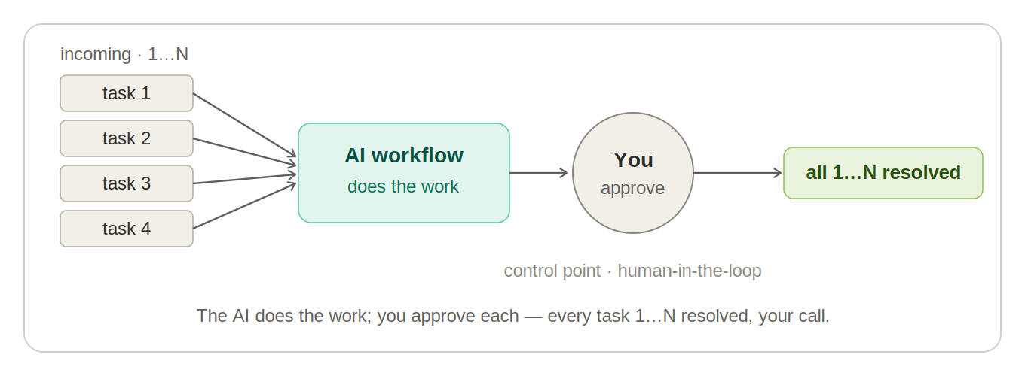
Build: 4 task chips → “AI workflow / does the work” unit → a circle “You / approve” (the control instrument) → green “all 1…N resolved”. The circle echoes Slide 2 on purpose — there You are the whole process; here You are just the control point.
Why this works: the two diagrams are a matched pair, so the problem→solution contrast lands across the slides. A process engineer on the jury reads them instantly, and the control-point circle carries the “human keeps control” message visually — no words needed.

C. Slides 2 vs Market — the four buckets appear twice
Slide 2 lists Messages / Documents / Quotes & renewals / Reports as problems; the Market slide (now Slide 4) lists the same four as segments. Both are required — don’t cut; make the repeat a deliberate callback.
Add to the Market slide (takeaway or sub): “The same four areas that cost you hours on the problem slide are exactly the segments we serve — we sell into the pain we opened with.”

D. “Human keeps control” — keep the refrain, vary the words
With Slide 4 gone, the refrain now lives on Slides 1, 3 and the Competition slide (now Slide 5). Keep it — it’s your differentiator — but say it differently each time:
Slide 1: “You keep the decisions.” (the promise)
Slide 3: “You still decide every item — the control point on the line.” (now carried by the diagram)
Slide 5 (Competition): “A person approves every step.” (the differentiator vs the four alternatives)

E. Pricing on the Financial slide vs the ROI example — no contradiction
The Financial slide (now Slide 7) is your numbers — price ranges, ARR, break-even; keep it. The cost-of-inaction / ROI example is the customer’s numbers — you say it aloud there if asked, never a second slide, never the spreadsheet on the projector.
Net: 9 slides, no repetition. Slide 4 removed; its point now shown — more accurately — by the two process diagrams on Slides 2 and 3.
vortexdeep.ch

